**DYNAMIC MIGRATION FLOW MODELLING**

**Vladimir Ninković, Faculty of Security Studies, University of Belgrade,** [**vladimirninkovic@yahoo.co.uk**](mailto:vladimirninkovic@yahoo.co.uk)

**Ozren Džigurski, Faculty of Security Studies, University of Belgrade,** [**odzigurski@gmail.com**](mailto:odzigurski@gmail.com)

**Zoran Keković, Faculty of Security Studies, University of Belgrade,** [**zorankekovic@yahoo.com**](mailto:zorankekovic@yahoo.com)

**Abstract**

The number of international migrants reached 244 million in 2015, including almost 20 million refugees. This number was further increased with the onset of the “Migrant Crisis” with a huge number of people abandoning conflict-torn countries of Syria, Iraq, Afghanistan, Libya etc. Taking into account that serious problems related to human migrations have existed throughout history, in the previous decades various models have been developed for the analysis of this field. The most common models have been the Lee Model and the Gravity Model. The Lee model applies so-called push-pull factors for the analysis of decisions for migrating, whereas the Gravity model of migration is derived from the Newton’s Law of Gravity, and is used to predict the degree of interaction between two spatial models. The Gravity model of migration is based upon the idea that the increase in interregional differences in socio-economic values between locations of migration origin and destination may induce increased flow between them, whilst the increase in distance between two locations may cause the tendency of migration to decrease. Both models, among many others, are used mainly for explanation of migration decision making and the migration management policies. The existing migration models based on System Dynamics (SD) are generally related to data analysis, policy making and migration management. The paper presents an SD model that analyses migrant/refugee flow, taking into account the following parameters: political decisions of the countries on migrant routes (political intervention), socio-economic factors, porosity of state borders, criminal activities, public opinion, health, climate and environmental conditions etc. The model was built and simulations performed using the *Vensim* modeling tool, the results of which may be used for prediction purposes, creation migration management scenarios, as well as for the risk and resilience assessment of the migrant routes.

**Keywords**: *migration model, system dynamics, simulation model, risk assessment, resilience*.

**1. Introduction**

The series of “Spring” events throughout the Middle East and Northern Africa has triggered the movement of vast number of refugees and migrants from those areas to Europe. Europe is currently witnessing a mixed-migration phenomenon, in which economic migrants and asylum seekers travel together and these groups overlap. This phenomenon is further exacerbated by the inconsistent methods with which asylum applications are often processed across the EU. (Park, 2015)

Despite of the size of this human and humanitarian tragedy, it is more of a constant, rather than an isolated occurrence throughout the history. The world history is a history of migrations. From prehistory and early antiquity until now, virtually there has not been even a brief period without tribes, clans, classes, families and individuals moving from a place to place, either escaping from dangers and hardships, or searching for better life. Some of those migrations have been caused by political, some by economic, and some by environmental changes. Paleo-Indian hunters entered the American continent at least twenty thousand years ago, whilst Indo-Europeans colonized Europe, Western and Southern Asia from Central-Asian steppes by the early second millennium BC, Bible tells of Judean exodus and Babylonian captivity. The middle of the first millennium AD in European history is even called the Migration Period when the “barbarians” broke into Roman Empire. And the list goes on.

Fast forward to the modern age. Hunger, plague, discovery of the “New World”, and the “invention” of the doctrine of the Total War caused many people to leave their households. In the XX century, the largest migration waves were observed during and in the aftermath of two world wars. As there was a steep increase in the world population, total numbers of refugees, migrants and internally displaced persons also increased. For instance, at the close of World War II there were an estimated 30 million refugees and displaced persons on the European continent, some dislodged by the war and others by the redrawing of Europe's boundaries. Furthermore, the emergence of newly independent states in Africa and Asia during the post-war years generated a new global refugee phenomenon. This process was accompanied by population exchanges, most severely in India and Pakistan, and by a succession of internal wars and violent conflicts. After the ebb during 70’s and early 80’s there was a significant flow during the late 80’s and 90’s due to the breakup of the Soviet Union, Warsaw Pact and the wars in Yugoslavia. (Weiner, 1996) This prompted some authors to describe the XX century as the century of migrations.

However, the same authors could not even suppose the extent this phenomenon would reach in the first half of the second decade of the 21st century. (Ninković, Kešetović, 2016) The wave of demonstrations and protests, riots and civil wars known as The Arab Spring (Arabic: الربيع العربي‎, ar-rabīˁ al-ˁarabī) and escalation of Syrian crisis in 2011 were trigger events for a great migrant flow from the Middle East and Africa towards Europe that intensified in 2014 and reached almost unimaginable dimensions during 2015. In fact, the 2013 United Nations projected number of migrants was largely surpassed in 2015, accompanied with equally high growth rate. Only two years ago, it was assumed that the total number of migrants on the global level would reach a maximum of 237 million, which represents a drastic increase in comparison with the year 1990, when the total number of migrants amounted to “only” 154 million (Simeunovic, 2015). Every attempt to quantify the number of migrants can give only a momentary and shaky figure that may be outdated after several days.

A significant number of migrants cross the borders illegally. According to data gathered by FRONTEX in 2014, detections of illegal border-crossing reached a new record, with more than 280.000 attempts. The unprecedented number of migrants illegally crossing the external borders has roots in the fighting in Syria that has resulted in the worst refugee crisis since the Second World War. Indeed, most of the detections at the borders concerned migrants from Syria, who later applied for asylum within the EU. Most migrants were detected in the Central Mediterranean area, where detections totalled over 170.000. On the Eastern Mediterranean route detections totalled over 50.800. Towards the end of 2014, detections sharply increased at the Hungarian land border with Serbia, making the Western Balkan route (with 43.357 detections) the third most important irregular migration route towards the EU (FRONTEX, 2015).

Saying that the current migrant crisis is affecting the Western Balkans would be an understatement. One of the most used ways towards rich countries of the West goes via Balkan Peninsula – Greece, Bulgaria, Macedonia, Serbia and Croatia. There are also other routes, from Northern Africa across the Mediterranean Sea to Spain or Sicily, through ex-Soviet republics etc. In addition, there is a constant influx of migrants from Mexico and Central American countries into USA, from South-East Asia to Australia, to mention just a few.

Despite their large numbers in historically and geographically various settings, all migrations show similar traits which enables creation of migration models and simulations. In our paper we will first present several most important approaches to migration modeling, in particular gravity and Lee’s push-pull model. In the second part of the paper we will explain how systems theory in general, and system dynamics in particular can be used in migration modeling. Finally we will present the results of the simulation and draw conclusions from it.

**2. Migration models**

Human migration is one of the few truly interdisciplinary fields of research of social processes which has widespread consequences for both individuals and the society. Human migrations can be considered as demographic, economic, ethnologic, geographic, political, psychological or social process. One of the first attempts to formalize the study of migration processes was done by the English geographer Ernest Ravenstein. Ravenstein's idea was that the principal factors of migration, though not the only cause of migration, are economic. As pointed by him, bad or oppressive laws, heavy taxation, an unattractive climate, uncongenial social surroundings, and even compulsion (slave trade, transportation) produce flows of migrants. Ravenstein's basic laws, subsequently amended by additional laws derived from his work, serve as the starting point for virtually all mathematical models of migration processes. (Ravenstein, 1885)

Lee (1966) revised Ravenstein’s XIX century laws on migration and proposed a new analytical framework for migration. In his view, the decision to migrate is determined by the following factors: factors associated with the area of origin; factors associated with the area of destination; so-called intervening obstacles (such as distance, physical barriers, immigration laws, and so on); and personal factors.

A breakthrough in mathematical modeling of migration dates back to the 1930s, which led to the appearance of different micro and macro models. A significant contribution to the development of migration modeling in the 20th century was made by the improvement of the mathematical methods used in demography, first of all – econometrics.

**2.1. Classification of migration models**

*A mathematical model of migration* is a simplified description of real migration processes, where all the crucial links between the real "participants" of spatial movements – migrants and factors of migration – are expressed mathematically. As a social-economic process; migration modeling can be applied to both, macro and micro levels. Given the same object of research – population – these two approaches differ in the subject and the goals of research. (Aleshkovski & Iontsev, 2005)

*The macro approach* studies the patterns of migration of the whole population or certain social groups (for example, seniors, population in working-age period, ethnic groups, etc.) within a framework of a given territory and is based on either census data or current statistics. Characteristics of the origin and destination regions (such as climate, income, unemployment, etc.) are used as input variables for macro models of migration, migration processes indicators (such as migration increase, etc.) – as output variables. The core ultimate goals of application of migration modeling at macro level are: migration processes analysis, migration indicators forecast and simulation of migration process development using the analysis of possible changes in emigration under different scenarios of economic growth in the emigration countries.

*The micro approach* focuses on the migration behavior of individuals (families, households) and intends to explain the decision-making process by potential migrants to remain in a current residence or to migrate to another one. As input variables micro models use both the characteristics of the origin and destination regions and the characteristics of individuals involved in migration processes. Output variables can describe migration behavior of a representative individual or, as in the case of macro models, aggregate indicators of migration processes. The core ultimate goals of application of migration modeling at micro level are: analysis of the decision-making process by potential migrant and analysis of the individuals selection process between alternatives.

Despite the fact that macro and micro approaches to modeling have traditionally evolved independently from each other, actual migration flows are always the result of a combination of decisions made by individuals. According to the underlying basics and the mathematical methods used, micro and macro models of migration can be classified into several categories.

According to the modeling approach migration models can be characterized as *deterministic* and *stochastic* models. A model is classified as *deterministic*, if the result of any system change can be predicted unambiguously. *Stochastic* models, on the other hand, provide several output values given the same input value, whereas some likelihood values correspond to all the attainable outcomes, in order to reduce the uncertainty.

According to the time period migration models can be classified as *static* or *dynamic*. *Static* models refer to the state of migration processes at a particular point in time, whereas *dynamic* models consider the interaction between the variables in time. *Dynamic* models are mainly used for the purposes of migration processes forecasting.

Chronologically, the *interaction models*, or the *models of spatial interaction* came first. They are based on the idea of analogy of the processes undergoing within physic and social systems and, correspondingly, the idea of the methodological unity. The conclusion can be drawn that the population is comparable to a simple system of elementary particles, whose existence and motion follow the rules similar to physical, and the society is a vast mechanism, where migration and concentration of people-molecules proceed as the result of the implementation of the "gravity forces" between aggregate groups of people, i.e. the distance of motion rises as the size of the group goes up, and falls in case the distance between two groups increases.

With respect to peculiarities of the migration modeling, interaction models can be classified into *gravity models*, *intervening opportunities models* and models based on the *general theory of movement*.

The other important types of Macro models are Migration Factors Models (Pull-Push Migration Models) and Markov Chain Migration Models, as well as Migration Processes Diffusion Migration Models and Human Capital Models of` Migration pertaining to the subset of Micro models.

Now, we will take a more detailed look at the main types of Macro migration models - Gravity and Lee models.

**2.2. Gravity models of migration**

The majority of the interaction models belongs to *gravity models of migration*. These models consider spatial mobility of population in analogy with Isaac Newton's Law of Gravitation (1687) as interaction between two territorial units (i.e. countries, regions, etc.) (see Figure 1).

***Mj***

***dij***

***Mi***

Figure 1. Scheme of spatial interaction of two territorial units within the gravity model of migration

This "law" says that migration between two regions i and j is directly proportional to the product of population sizes of these regions and inversely proportional to the square of the distance between them. Hence classical gravity model is a special case of migration interaction model where population: of regions of origin and destination of migrants are used as the masses of interacting bodies.

Advantages of models of this type include, first of all, relative simplicity of developing and availability of statistical data for all level of analysis (inter-state, interregional migration, etc.).

The gravity model is a popular mathematical model used to predict the interaction between two or more places. In geography it has been used to simulate a variety of flow patterns, such as traffic and mail flows, telephone calls, and migration. Essentially, the gravity model can be used to account for any interaction or flow that is expected to move from one place to another. This idea has generated many mathematical manipulations of the model.

The original gravity model is based on Newton's law of gravitation, expressed as:

***Gij = G $*$ ( Mi Mj / dij2 )***

where *Gij* is the gravitational bond between objects *i* and *j*, *G* is the gravitational constant, *Mi* and *Mj* are measures of the attractiveness of masses *i* and *j*, and *dij2* the square of the distance between objects *i* and *j*. (Sink, 2010) The theoretical principle of the gravity model is twofold: (1) the degree of interaction is directly proportional to the size of the masses and (2) the degree of interaction is indirectly proportional to the distance that separates them. For the use in gravitational migration model, the denominator in the formula has the form of *dijb*, in which *b* is the friction of distance. Larger values of *b* indicate that the interaction between *i* and *j* declines more rapidly with increased distance.

Generally, three types of gravity model have evolved since the original formulation: (1) origin-specific, (2) destination-specific, and (3) network or potential models. The basic gravity model formulation is the foundation of origin-and destination-specific models. Commonly, origin-specific models are used to predict flows from one place of origin to several destinations. With destination-specific models, flows are predicted from several origins to one destination. The gravity model was later reformulated to account for a network of interactions between places. These are known as potential models. Results of the potential model show the position of each place relative to all other places. Often, the results are illustrated spatially with a potential surface map.

Most criticism of the gravity model has concerned its use as a predictive tool. Some note that the model is not based on observation and therefore cannot be substantiated scientifically. Others believe that the model is biased toward existing spatial patterns and that this will perpetuate the status quo.

**2.3. Lee’s model of migration**

For the motivations for migration we can consider how relationship between two points (origin and destination) is affected by *push factors* and *pull factors* . Push factors exist at the point of origin and act to trigger emigration; these include the lack of economic opportunities, religious or political persecution, hazardous environmental conditions, and so on. Pull factors exist at the destination and include the availability of jobs, religious or political freedom, and the perception of a relatively benign environment. Pushes and pulls are complementary — that is, migration can only occur if the reason to emigrate (the push) is remedied by the corresponding pull at an attainable destination.

Figure 2. summarizes Lee's (1966), push-pull theory in graphic form. It shows possible migration between a place of origin and a place of destination, with positive and negative signs signify pull and push factors, respectively. Flows take place between two places, but there are intervening obstacles to these spatial movements. Although these obstacles are represented by "mountain" shapes, the obstacles need not be limited to physical barriers. Restrictive immigration laws, for example, can present a formidable barrier to prospective migrants. Note that both the origin and destination have *attributes - pushes and pulls*, reflecting the reality that any migrant must consider both the positives of staying and the negatives of moving, as well as their converses. The logic of the push-pull theory is that if the plusses (pulls) at the destination outweigh the plusses of staying at the origin, as shown below, then migration is likely to occur.

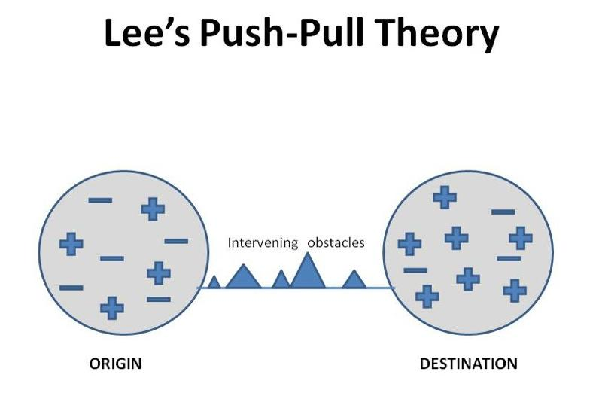

Figure 2. Lee's Push-Pull Theory

The flow of migrants between two places may not totally develop if *intervening obstacles* exist between them. The intervening obstacles refer to any barriers to spatial interactions, in this case physical, economic, cultural or political impediments to migration. The number of migrants is directly proportional to the number of opportunities at a given place and inversely proportional to the number of intervening obstacles. Therefore, the volume of migration from one place to another is associated not only with the distance between places and number of people in the two places, but also with the number of opportunities or obstacles between each place. This is especially true in labor migration.

**3. Migration systems theory**

Unlike transitional models that focus on how broader processes of development affects migration, migration systems theory draws a two-way, *reciprocal* and *dynamic* link between migration and development, and therefore seems particularly relevant for elaborating a theoretical framework, which puts migration in a broader development perspective.

Migration systems theory (de Haas, 2008), defines a migration system as a set of places linked by flows and counterflows of people, goods, services, and information, which tend to facilitate further exchange, including migration, between the places. Borrowing from general systems theory it is focused on the role of information flows and feedback mechanisms in shaping migration systems. This theory stresses the importance of feedback mechanisms, through which information about the migrants’ reception and progress at the destination is transmitted back to the place of origin.

Migration systems theories primarily focus on the factors that cause, shape, and perpetuate migration. In particular migration systems theory is useful in describing and modeling processes of spatial geographical structuring of migration patterns, and, as a spatiotemporal model, it can be well integrated within the dynamic transitional models of migration-development interconnections. Taken together, they help to understand how migration evolves over time - and changes in its nature, magnitude, destinations, and selectivity - and is reciprocally linked to the broader process of development. This theoretical perspective is fundamentally conflicting with and superior to static and a-historical push-pull, neo-classical and structuralist approaches, which all draw on the – erroneous – sedentary notion that migration and development are substitutes rather than complements.

**3.1 System dynamics migration models**

System Dynamics (SD) was invented in mid 1950s by Jay Forrester of the Massachusetts Institute of Technology (MIT) to improve the ability to understand complex systems. (Forrester, 1961) At the beginning it was mainly used in business practice. In the following years, other science disciplines than business management got interested and nowadays, SD is applied in the field of environmental and political science, economics, medicine, engineering and development amongst others. By framing the underlying structure of a complex system, System Dynamics is supposed to reproduce the observed behaviour.

System dynamics enables joint analysis of the migration phenomenon in the location/country of its origin, with the location/country of its destination. The SD approach allows analyzing the migratory phenomenon by integrating in the same analysis a set of quantitative and qualitative variables that influence and determine this phenomenon. This approach also allows studying the migration phenomenon from the perspective of the complex systems. (Chávez et al, 2011)

System Dynamics is defined as a "computer simulation of continuous, non-linear feedback systems, emphasizing an endogenous point of view".

The main concepts of SD are feedback thinking, which can be reinforcing or counteracting, the distinction between stocks and flows, being responsible for delays in the system, and the endogenous point of view -necessary for shifting loop dominance and the inclusion of non-linearities.

The feedback concept is central to the SD approach. It means that there is a closed causal chain, a closed loop of mutual cause-and-effect, so that an effect perpetuates until it influences back to its initial cause, after having passed one or any number of variables before. A feedback loop can be positive or negative. Positive loops tend to reinforce or amplify whatever is happening in the system. Negative loops counteract and oppose change, so they are also termed as balancing or counteracting loops.

The second crucial concept refers to the important status of stocks and flows, Figure 3. As soon as SD models are used for simulation it needs to be identified whether a variable is a stock or a flow variable. Stock variables are accumulations and indicate the status of the system through time, whereas flows represent the rate of change: they increase or decrease a stock over some time interval, being either inflows or outflows. A stock can only be changed and thereby managed by a flow.

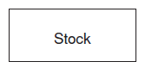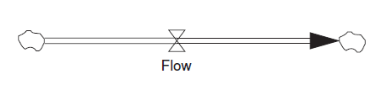

Figure 3. Stock and flow SD elements

The model developed for this paper aims at representing the causes and consequences of emigration from origin to destination countries, embedding them in the broader development context with the purpose of exploring the inherent feedback relationship of migration and development on a macro-level, as well as the behaviour of the system by means of simulations.

**4. SD migration/refugee flow model**

In this paper we consider population migration models constructed on the basis of different class of spatial epidemics models. The temporal-spatial migration models are obtained by adding classical spatial homogeneous epidemics terms into migration models; they have the form of nonlinear differential-integral equations. They describe the evolution of the density of a system of population living in a particular spatial domain. The above also means that dynamical behavior of a population system with migration is very complex.

Namely, individuals in this population system can move from one location to the other with a rate (***v***) determined by characteristics of their departure and arrival locations and other non-spatial factors. There are two categories of variables: *endogenous* and *exogenous*. *Endogenous* are spatial/security factors, whereas socio/economic, psychological and other relevant factors pertain to *exogenous* variables. (Simonović & Ahmad, 2010)

The migration rate function (***v***) determines to a great extent the dynamical behavior of the population system. The SD migration/refugee flow model can be generally based on:

***Migration_rate(v)=f(socio/economic factors, spatial characteristics)*** (1)

For the development of SD model we first consider the migration SI model, which is obtained by adding migration terms into the classical SI epidemic model. Further, we considered the migration models obtained on the basis of more complex epidemic models: SIS, SIR, SEIR and MSEIRS. For detailed analysis and development of the complex migration model we adopted the MSEIRS model (Hethcote, 2005), as well as its broadened version MSEIRWS model [*Maternally derived immunity – Susceptible –Exposed – Infected - Recovered - Waned (low immunity) - Susceptible*] (Goeyvaerts et al, 2011), Figure 4.

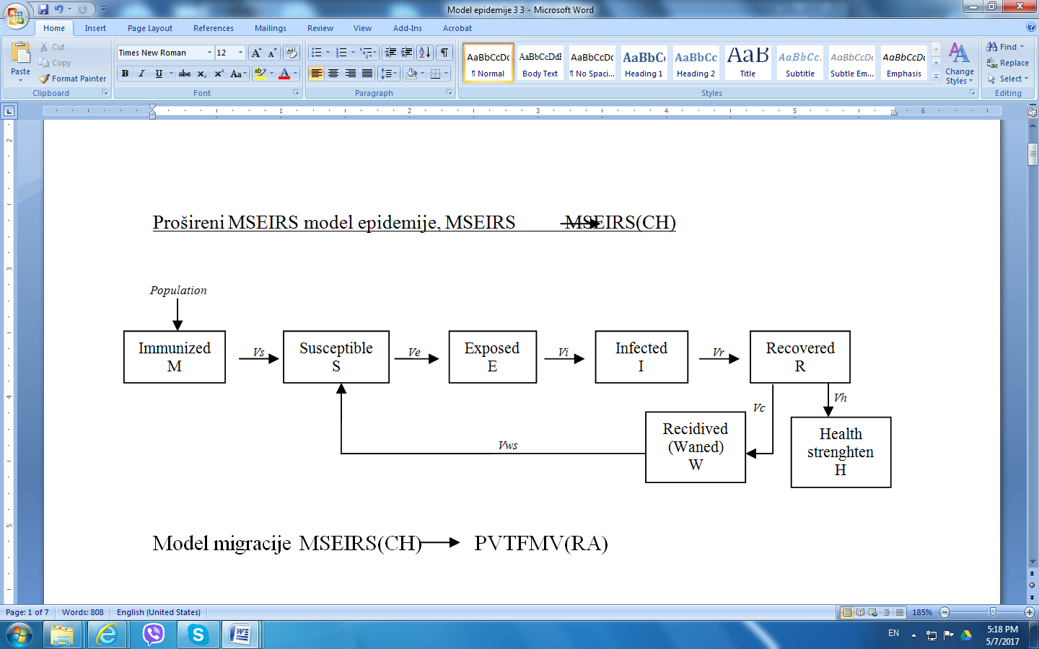Figure 4. - MSEIRWS epidemics model

On the basis of the epidemics model, the analogue migration SVTFMRV [*Safe – Vulnerable – Threatened – Migration Flow – Migrated – Readmitted (no asylum) – Vulnerable*] was developed, Figure 5.

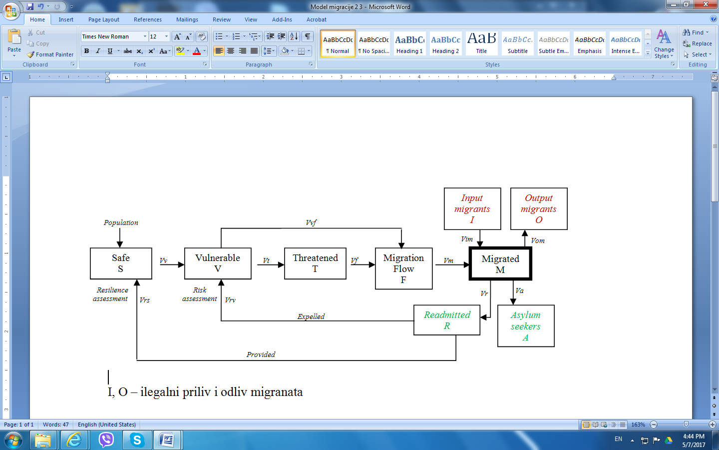

Figure 5. SVTFMRV migration model

In Figure 5, the *I* and *O* blocks, represent inflow and outflow of illegal migrants. Besides that, those blocks may be used for connection with other migration models from different spatial locations. In that way it is possible to form a network migration model that represents migration flows at a broader geographic area.

As we have already mentioned, migration models have the form of very complex nonlinear differential-integral equations, which are possible to represent as a mathematical model. However, for the realization of the computer simulation SD migration/refugee flow model we used the Vensim simulation software that primarily supports continuous simulation - system dynamics. This software tool enables direct formation of simulation model on the basis of *Causal Loop Diagram* (CLD) that aids in visualizing how different variables are interrelated in the system. Moreover, on the CLD basis a simulation model is developed, which is further used for the analysis and simulation of migration flow processes. This way a formation of a complex mathematical model can be avoided, taking into account that *Vensim*, on the CLD basis, internally realizes all mathematical relations of the model and forms a situational model.

Figure 6. represents *Vensim* simulation SD migration/refugee flow model.

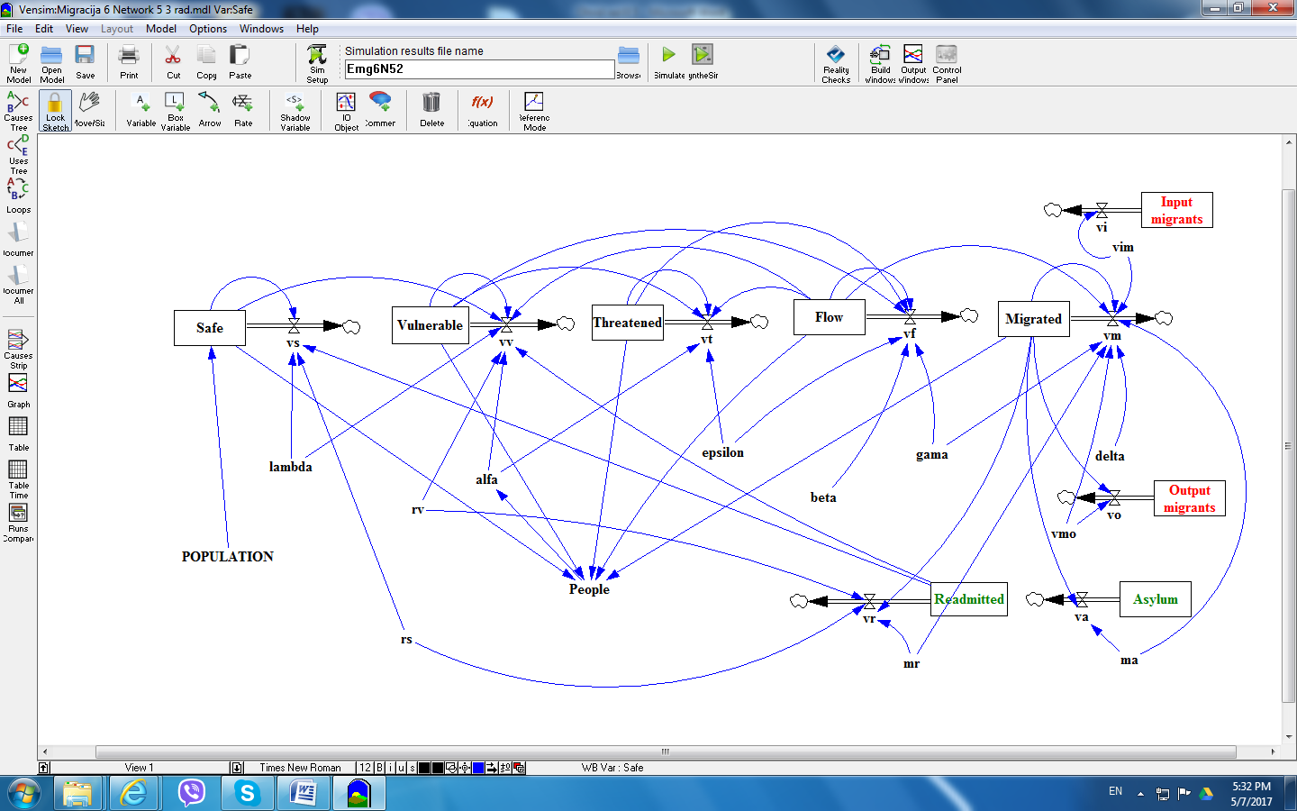

Figure 6. SD migration/refugee flow model

In Figure 6, the variables *rv, rs, mr, ma, vmo, vim* - represent the constants that define the dynamics of certain processes – stocks, as well as their mutual interaction. These values are defined on the basis of statistic and experience data, as well as through experiments during testing and adjusting of the model.

The meaning of other variables in the model - *alpha, beta, gamma, delta, epsilon, lambda*, is represented in the following table:

Table 1. Description of variables in the model

|  |  |
| --- | --- |
| variable | Description |
| *alpha* | transmission rate from *Vulnerable* to *Threatened* |
| *beta* | transmission rate from *Vulnerable* to *Flow* |
| *gamma* | transmission rate from *Flow* to *Migrated* |
| *delta* | rate of changing of *Migrated* |
| *epsilon* | transmission rate from *Threatened* to *Flow* |
| *lambda* | rate of changing of *Safe* |

The values of these variables are defined on the basis of statistic and experience data. In addition, the data and factors obtained from other migration models, such as various gravity, push-pull and other models. Those variables can be time-varying and represent aggregate values obtained on the basis of differing external parameters that define temporal and dynamic characteristics of stock variables in the model. Hence, for instance, the variable *epsilon* (transmission rate from *Threatened* to *Flow*), can be represented as, based on the expression (1):

*epsilon = e1 $*$ [internal_factors] + e2 $*$ [external_factors] + +e3 $*$ [psychological_factors]* (2)

in which weighting factors e1, e2, and e3 are defined on the basis of statistic and experience data. Furthermore, the factors in the expression (2), can be, for instance, represented in the following manner:

*internal_ factors = a1[$*$ risk_assessment] + a2[$*$ social_factors] + +a3[econom $*$ ic_factors]* (3)

*external_ factors = b1 $*$ [security_factors] + b2 $*$ [spatial_factors] +* +*b3 $*$ [refugee_factors]* (4)

*psychological_ factors = c1 $*$ [population_factors] + c2 $*$ [danger_recognition]+ + c3 $*$ [evacuation_decision]* (5)

All factors in the expressions 2, 3 and 4 can be further decomposed into other elements. Thus, for example, the factor *evacuation_decision* in expression (5) can be represented as:

*evacuation_decision = d1 $*$ [situation_acceptance] + d2 $*$ [experience_factor]+ +d3*[support_ factor]* (6)

It should be stressed that all these factors and their components can be time-varying. The identification of these factors is a complex process and depends on the concrete application of the simulation model, expert knowledge in the migration modeling and accessible statistic and other data.

Similarly, as showcased in expressions 2, 3 and 4, other variables from Table 1. can be defined.

**4.1. Results of simulation**

As we have previously mentioned, for the realization of the computer simulation SD migration/refugee flow model we used the *Vensim* simulation software modeling tool that supports continuous simulation and system dynamics. This software tool enables direct simulation of the model on the basis of *Causal Loop Diagram* (CLD) that aids in visualizing how different variables are interrelated in the system. Due to the limited space in the paper, we have not represented the CLD.

By performing multiple simulations and parameter calibrating in the model we may obtain various data on migration processes and flows, in local or wider areas. The data analysis can provide insight in certain migration activities, and the analyzed data can be used for prognostic or decision making purposes.

In this paper, we limited ourselves on representing model response for two stock variables, *Migrated* and *Readmitted*, (Figure 7) and for two flow variables *vm* (migrated) and *vr* (readm itted), (Figure 8).

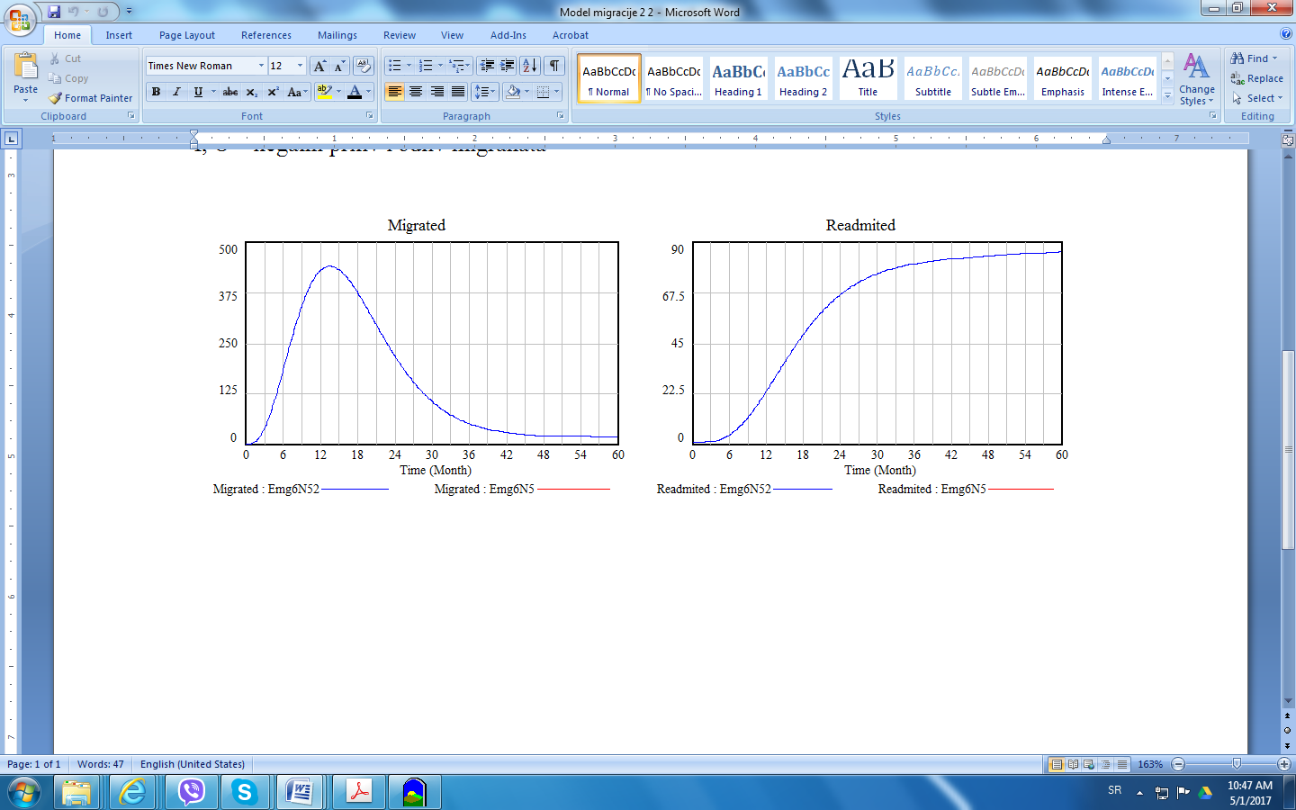

vm.wmfFigure 7. Model response for stock variables *Migrated* and *Readmitted*

vr.wmf

Figure 8. Model response for flow variables *vm* (migrated) and *vr* (readmitted).

In a similar way the model response for all other model variables, as well as their combinations, can be represented, which we had to omit here due to the limited space.

This is a pilot model, in the early stage of development. The development of complete and concrete SD migration models is a complex and time-consuming task that would require engagement of a multidisciplinary team of experts. For instance, in the early stage of the model development, the data about the Balkan Route presented in the first section of the paper, may be taken into account, until the access to the raw data and expert opinions is secured.

**5. Conclusion**

Mass migrations have been a constant throughout the human history. However, due to the globalization and developments in technology, especially in transport their frequency and volume intensified in the recent decades. The attempts to represent the migrations through models have been existent ever since XIX century, but there is a lack of models that would include time-varying state of the system in which the migrations occur.

In this paper we proposed the method of System Dynamics (stock and flow diagram) for creation of dynamic model of migrations. We designated our model as SVTFMRV named after the stocks in the model: *Secured, Vulnerabled, Threatened, Flow, Migrated, Readmitted* and *Vulnerabled*. The model is derived from an existing epidemics and infection model, and is analogous with the MSEIRWS epidemics model. Therefore, SVTFMRV model can serve as the basis for concrete scenarios applicable on, for instance, the Balkan Route. Besides that, this model may be used for connection with other similar migration models from different spatial locations. In that way it would be possible to form a network migration model that would represent migration flows at a broader geographic area.

The model that we offer is of conceptual nature. This is a pilot model, in the early stage of development, as the development of complete and concrete SD migration models is a complex and time-consuming task that would require engagement of a multidisciplinary team of experts. The model was built and simulations performed using the *Vensim* software modeling tool, the results of which may be used for prediction purposes, creation migration management scenarios, as well as for the risk and resilience assessment of the migrant routes.

**References**

1. **Aleshkovski I., Iontsev V.** (2005) “Mathematical Models of Migration, Systems Analysis and Modeling of Integrated World Systems” in. Encyclopedia of Life Support Systems (EOLSS), Developed under the Auspices of the UNESCO, EOLSS Publishers, Oxford ,UK [<http://www.eolss.net>].
2. **Chávez J., Rodríguez J., Wilkie J.** (2011) “A System Dynamics Model of Employment and Migration for Michoacán” in: PROFMEX Journal Mexico and the World Vol. 17.1.
3. **de Haas, H.** (2008) Migration and Development - A Theoretical Perspective. International Migration Institute, University of Oxford.
4. **Edwards A.** (2015) “UNHCR viewpoint: ‘Refugee’ or ‘migrant’ – Which is right?” Accessed on 25.4.2017.

URL: <http://www.unhcr.org/55df0e556.html>

1. **FRONTEX** (2015) Annual Risk Analysis 2015, Warsaw.
2. **Forrester J.W.** (1961) Industrial Dynamics. Cambridge, Mass, The MIT Press.
3. **Goeyvaerts N., Hens N., Aerts M., Beutels P**. (2011) “Model structure analysis to estimate basic immunological processes and maternal risk” in: Biostatistics. 12, 2, pp. 283–302.
4. **Hethcote, H.W.** (2005) The Basic Epidemiology Models, Master Review, Vol. 9.
5. **Kešetović Ž. & Ninković V.** (2016) “Migrants and Local Extremists in South-Eastern Europe”, in Čaleta, D & Shemella, P (eds.) Comprehensive Approach to Counter-Radicalism and Extremism – Future Challenges for Counter Terrorism Process. Ljubljana, pp.101-114.
6. **Lee E.S.** (1966) “A Theory of Migration” in: Demography. Vol. 3, No. 1, pp. 47-57.
7. **Park J.** (2015) “Europe’s migration crisis”. CFR Backgrounders. Council of Foreign Relations. Accessed on 28.4.2017.

URL: <http://www.cfr.org/migration/europes-migration-crisis/p32874>

1. **Ravenstein E. G.** (1885). “The Laws of Migration” in: Journal of the Statistical Society of London. Vol. 48. No.2, pp. 167-235.
2. **Simeunovic D.** (2015) "Migracije kao uzrok političkih anomalija u Evropi"/"Migrations as reason for the political anomalies in Europe" in: NBP - Journal of Criminalistics and Law, Vol XIV, No. 3. pp.1-18
3. **Simonovic S.P., Ahmad S.** (2005) “Computer-based Model for Flood Evacuation Emergency Planning” in: Natural Hazards. 34: 25–51
4. **Sink, T.** (2010) Gravity Model, Encyclopedia of Geography. SAGE Publications.
5. **UNHCR.** (2011) Convention and Protocol relating to the status of the refugees.
6. **Weiner M.** (1996) “Bad Neighbors, Bad Neighborhoods: An Inquiry into the Case of Refugee Flows” in: International Security. Vol 21, No.1, pp.5-42.