DISASTER MANAGEMENT IN URBAN SETTLEMENTS – RESILIENCE APPROACH
UPRAVLJANJE KATASTROFAMA U URBANIM NASELJIMA – PRIMENA PRISTUPA REZILIJENTNOSTI
Zoran KEKOVIĆ, Vladimir NINKOVIĆ, Ozren DŽIGURSKI
Faculty of Security Studies, University of Belgrade
zorankekovic@yahoo.com, vladimirninkovic@yahoo.co.uk, odzigurski@gmail.com,

Abstract
This paper explores the notion of resilience and its application to the research, planning, design and management of urban settlements at various scales. The notion of resilience is an all-hazard approach related to the capacity of systems to adapt to disruptions without them changing to entirely different states, which in the case of human settlements often results in catastrophic consequences for the inhabitants. The paper will present several approaches for enhancing existing settlements, as well as creating new ones, to be better prepared to confront natural and man-made hazards. Particular focus is on future environmental and climate changes, both predicted and unpredicted, as they occur, such as increasing intensity and frequency of extreme weather events, as well as more gradual changes.
Key words: resilience; community resilience; disaster management; urban settlements; capacities.
Apstrakt
Rad istražuje koncept rezilijentnosti i njegovu primenu na planiranje, projektovanje i upravljanje urbanim naseljima na različitim nivoima odlučivanja. Rezilijentnost - otpornost je pristup orijentisan na sve (moguće) pretnje i povezuje se sa kapacitetom sistema u cilju da se prilagodi remetilačkim događajima, ne menjajući se potpuno u drugačija stanja, što u slučaju urbanih naselja često ishodi katastrofalnim posledicama po njihove stanovnike. Rad će prikazati nekoliko pristupa za poboljšanje otpornosti postojećih i za projektovanje budućih urbanih naselja, kako bi bila bolje pripremljena na suočavanje sa prirodnim katastrofama i akcidentima izazvanih ljudskim faktorom. Poseban akcenat stavljen je na buduće promene u životnoj sredini i klimi, predvidljive i nepredvidljive, kao što su povišeni intenzitet i učestalost ekstremnih vremenskih nepogoda, kao i na promene koje mogu da nastanu postepeno.
Ključne reči: rezilijentnost; rezilijentnost zajednice; upravljanje katastrofama; urbana naselja; kapaciteti.

Introduction
Globally, 80 per cent of the largest cities are vulnerable to severe impacts from earthquakes, 60 per cent are at risk from storm surges and tsunamis, and all face new impacts caused by climate change. The cost of urban disasters during 2011 alone is estimated at over US $380 billion, with the largest impacts felt in Christchurch, New Zealand; Sendai, Japan; and Bangkok, Thailand. With 50% of the world’s population already in cities, and substantial urban population growth projected over the coming decades, there is a pressing need for new tools and approaches that strengthen local administrations and citizens to better protect human, economic, and natural assets of our towns and cities.
Resilience refers to the ability of human settlements to withstand and to recover quickly from any plausible hazards. Resilience against crises not only refers to reducing risks and damage from disasters (i.e. loss of lives and assets), but also the ability to quickly bounce back to a stable state, as well as to successfully adapt to new circumstances. While typical risk reduction measures tend to focus on a specific hazard, leaving out risks and vulnerabilities due to other types of perils, the resilience approach adopts a multiple hazards approach, considering resilience against all types of plausible hazards.
Human-made disasters, such as conflicts and technological disasters, can also undermine the development gains of countries and cities. The number of people at risk is increasing significantly, with rapid urbanization inducing uncontrolled and densely populated informal settlements in hazard-prone areas. The lack of capacity of cities and local governments to regulate building standards and land use plans exacerbates the risk of those living in vulnerable conditions. Local governments are the closest level to citizens, and have a huge role to play in delivering critical infrastructure and services to protect lives and assets during crisis response. Not only cities and local governments, but in the first place their citizens, need to increase their capacity to reduce both the damage and the recovery period from any potential disaster. According to the US Academy of Sciences Committee on Increasing National Resilience to Hazards and Disasters capacity building starts with individuals taking responsibility for their actions and moves to entire communities working in conjunction with local, state, and federal officials, all of whom need to assume specific responsibilities for building the national quilt of resilience (USA Academy of Sciences, 2012).

Community Resilience
The World Resources Institute defines resilience as ‘the capacity of a system to tolerate shocks or disturbances and recover’ and argues that this depends on the ability of people to ‘adapt to changing conditions through learning, planning, or reorganization’ (World Resources Institute, 2008). Resilience, therefore, can be related to the way that societies adapt to externally imposed change.
According to the Australian National Strategy for Disaster Resilience a disaster resilient community is one that works together to understand and manage the risks that it confronts. Disaster resilience is the collective responsibility of all sectors of society, including all levels of government, business, the non-government sector and individuals (National Strategy for Disaster Resilience, 2011).
British Department for International Development (DFID) defines disaster resilience as the ability of countries, communities and households to manage change, by maintaining or transforming living standards in the face of shocks or stresses - such as earthquakes, drought or violent conflict - without compromising their long-term prospects (DFID, 2011).
The promotion of resilience related strategies in the field of emergency and disaster management has been premised on a re-evaluation of the referents of security governance. In particular, the ‘myth-busting’ of panic in emergency situations, together with the notion that human populations actually possess significant adaptive and self-organizational capacities in emergencies have been instrumental in the advent of the notion that government should not look to direct, but to supplement and encourage the natural tendencies of those in emergency events to help themselves. Rather than withholding information, for fear of inciting of panic, populations in emergency should be provided with all the information they require to self-organize an evacuation or response (Zebrowski, 2013:2). Thus, for instance, the acknowledgement that panic is a ‘myth’ has caused a profound reorganization of UK emergency governance at the turn of the century (Zebrowski, 2013:3). Indeed, in the last fifteen years or so, the resilience strategies of UK Civil Contingencies are instead oriented towards facilitating and optimizing the natural, self-organizational capacities, or ‘resilience’ of populations in emergency (Zebrowski, 2009).
Normally, three general resilience capacities are mentioned in the literature – absorptive, adaptive and restorative, whilst some also add the predictive capacity. Absorptive capacity is the degree to which a system can automatically absorb the impact of system perturbations and minimize consequences with little effort. Adaptive capacity is the degree to which the system is capable of self-organization for recovery of system performance levels. Finally, the restorative capacity is the ability of a system to be repaired easily – either to its original, pre-event state, or to a completely new state that anticipates future system requirements (Keković et al, 2014).
The Figure 1 represents the Resilience aspect of the system's response to accident.

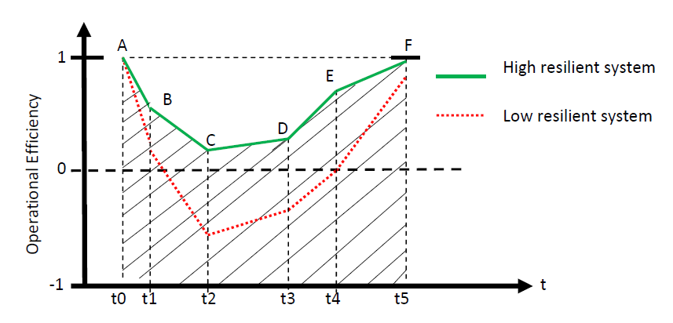
Figure 1 - Resilience Evaluation Curve

t0 – accident start, t5 - end of the system's response to accident
t0-t1 Predictive resilience phase
t1-t2 Absorptive resilience phase
t2-t3 Adaptive resilience phase
t3-t4-t5 Restorative resilience phase

Polygon P0 (t0-A-F-t5-t0) – ideal resilient system
Polygon P1 (t0-A-B-C-D-E-F-t5-t0) – real resilient system

Resilience measure (ratio of the polygons surface area) R = P1/P0

Furthermore, a lower layer of resilience assessment – resilience capacity features (such as redundancy, robustness, segregation etc) the existing design implementations that contribute to one or more of the system capacities may be used for reaching more precise conclusions about the state of the Human Security in accordance with its dimensions and indicators. About the highest layer of community resilience assessment - dimensions (the aspect that answers to the question “What elements should be judged by their resilience capacities (and features)?”), there is still no consensus about what they would be. The authors of this paper recently argued that the basis for the resilience dimensions may be seven Human Security elements (economic, food, health, ecological, personal, community and political security), within whom then more precise community resilience dimensions may be identified. Human security, as a preventative concept, is easily connected with the Risk Assessment paradigm (Ninković, Džigurski and Pavlović, 2016).
There have been some similar efforts to identify Community Resilience dimensions. For instance Mayunga (2007:4) defines Community Disaster Resilience as the “capacity or ability of a community to anticipate, prepare for, respond to, and recover quickly from impacts of disaster”. To further operationalize this he uses a framework of five areas of capital: Social, Economic, Human, Physical, and Natural capital integrated with indicators of resilience for each area. Mayunga is proposing a Community Disaster Resilience Index in order to quantify the concept, but at the same time he concludes that this is a complex and difficult task in order to capture all relevant data (Mayunga 2007:13).
Human security (HS) and Resilience (RES), together with RISK management, are two complex approaches for dealing with uncertainties that have figured prominently in the academic research in the past two decades. Due to the development theoretical framework, HS concept enables more precise and grounded identification of resilience characteristics and indicators for disaster management purposes.
Using the emergency (accident) response diagram and Resilience Evaluation Curve (Figure 1), it is possible to connect RES response phases with relevant RISK dimensions, in disaster management. That would enable research the possibilities of their (RISK and RES) mutual impact on the behavior of dynamic systems in accidents and disasters.
Vulnerability, perhaps, may be taken as the key variable that connects RES and RISK approaches in emergency situations. The Figure 2 conceptually represents how RES and RISK can with mutual activities as dynamic systems to impact stability and damage reduction of systems in emergency situations. This is a causal loop system dynamic diagram based on stocks and flows. The model was built using the modeling tool, VENSIM. This is a modified extension based of the Resilience in Civil Conflict model, originally done by Hayden (2014).
The main impact on the behavior of the system is done through the key variable vulnerability change. The system stability is influenced also by the baseline values of the following variables: Vulnerability, Resistance, as well as the RISK dimensions and RES capacities and features.
Starting from the Risk Assessment, it is possible to more precise define and identify HS indicators, which consecutively leads to the definition of composite RES indicators. Given a vast number of studies and projects in the field of RISK and HS assessment applied on informal settlements, this combinatory approach may facilitate efficient and complex management in disaster situations.

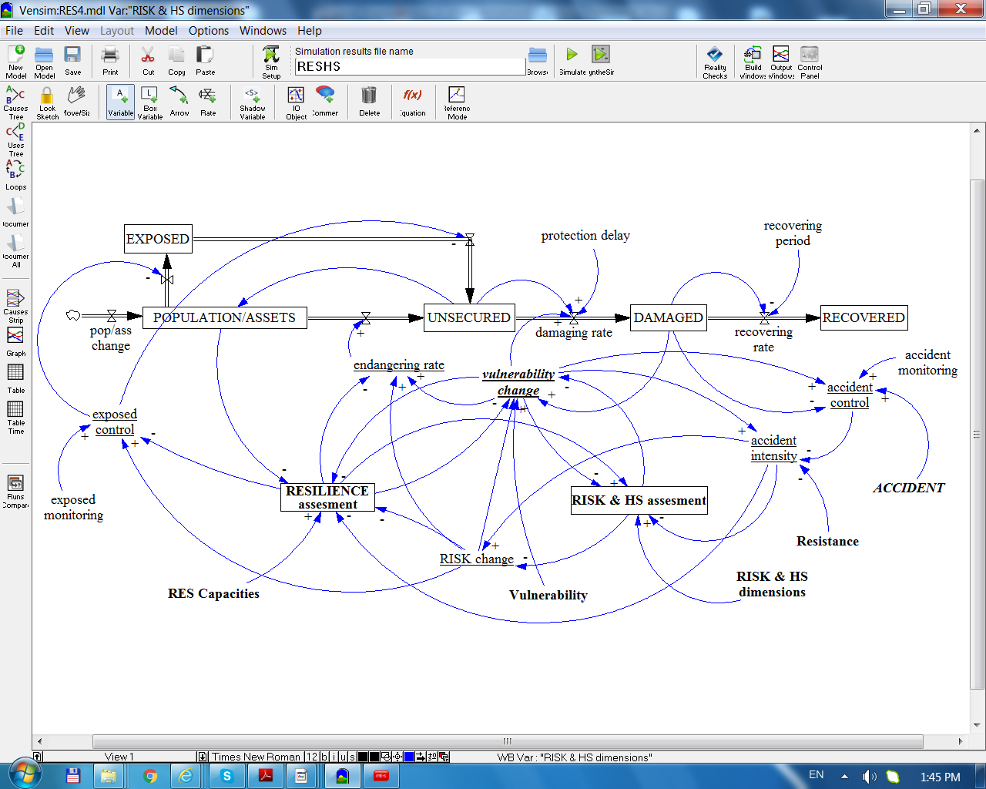

Figure 2. Integrated System Dynamic Model of Resilience and RISK/HS assessment in Disaster Management

Making a settlement resilient – current approaches
According to the UN-Habitat, urban planning may be one of the most important tools in reducing vulnerabilities and risk (UN-Habitat, 2006). It can help cities to significantly increase their resilience in coping with disaster risks and climate change (IFRC, 2010). Its importance relates to its potential to ensure planned adaptation. This consists of developing and investing in urban areas in order to reduce risks from climate-related impacts (and other hazards) and provide better protection for inhabitants, housing, infrastructure and enterprises (Bicknell, Dodman, & Satterthwaite, 2009).
Both disaster risk management (DRM) and climate change adaptation (CCA) have the ultimate goal to increase disaster resilience through incremental and more radical, transformative, changes (IPCC, 2012). CCA and DRM share the aim of reducing the occurrence and impact of climate-related disasters and associated risks; and consequently, the implementation of similar (or the same) measures and strategies at the local level (Wamsler, 2014; Rivera, 2016). In addition, both DRM and CCA have become cross-cutting issues that are a core element for sustainable development and resilience, but must be integrated into the work of different sectors (O'Brien et al., 2006; Wamsler, 2014). Here, sustainable development is defined as “a practical focus on integrating social, economic, and environmental considerations in urban development that considers the impact of today’s developments on future generations” (UN Habitat, 2011).
When we speak about settlements, we occasionally forget to include that apart from “regularly incorporated” cities, towns and villages, there are also informal settlements, mainly inhabited by vulnerable population. The growth of informal settlements can intensify the risks of social and ecological harm to their communities and to the wider urban area. The unplanned and poorly serviced character of these settlements raises the probability of disasters occurring. The public sector can increase these risks through indifference and poorly conceived actions or it can help to build resilience through a more constructive and integrated approach. (The case study from Stellenbosch in South Africa illustrates how a resilience perspective can highlight the systemic challenges surrounding the growth and management of informal settlements). It emphasizes the interactions between such places and their urban context, and recognizes the negative feedback loops that can exacerbate poverty and vulnerability. It proposes adaptive governance as a framework for building resilience through strengthening local capabilities. This flexible and engaged approach goes beyond “just managing” informal settlements to integrating them in a more positive way into the wider city or town.
An increasingly common methodology used by local governments and the international community to build resilience are the UNISDR’s “Ten Essentials.” (United Nations International Strategy for Disaster Reduction). UN-Habitat’s City Resilience Profiling Programme introduced the following “essentials” in order to further upgrade this framework by making it more rigorous, objective, and fit to conduct quantitative assessment and profiling of settlement resilience:
- Essential 1: Put in place organization and coordination to understand and reduce disaster risk, based on the participation of citizen groups and civil society. Build local alliances. Ensure that all departments understand their role in disaster risk reduction and preparedness.
- Essential 2: Assign a budget for disaster risk reduction and provide incentives for homeowners, low-income families, communities, businesses, and public sector to invest in reducing the risks they face.
- Essential 3: Maintain up-to-date data on hazards and vulnerabilities, prepare risk assessments, and use these as the basis for urban development plans and decisions. Ensure that this information and the plans for your city’s resilience are readily available to the public and fully discussed with them.
- Essential 4: Invest in and maintain critical infrastructure that reduces risk, such as flood drainage, adjusted where needed to cope with climate change.
- Essential 5: Assess the safety of all schools and health facilities and upgrade these as necessary.
- Essential 6: Apply and enforce realistic risk compliant building regulations and land use planning principles. Identify safe land for low-income citizens and upgrade informal settlements, wherever feasible.
- Essential 7: Ensure education programmes and training on disaster risk reduction are in place in schools and local communities.
- Essential 8: Protect ecosystems and natural buffers to mitigate floods, storm surges, and other hazards to which your city may be vulnerable. Adapt to climate change by building on good risk reduction practices.
- Essential 9: Install early warning systems and emergency management capacities in your city, and hold regular public preparedness drills.
- Essential 10: After any disaster, ensure that the needs of the survivors are placed at the centre of reconstruction, while supporting them and their community organizations to design and help implement responses, including rebuilding homes and livelihoods.
World Bank in 2012 published the Workbook on Planning for Urban Resilience in the Face of Disasters, based on the experiences of three cities in Vietnam - Can Tho, Dong Hoi, and Hanoi - that worked with international and local experts under World Bank supervision to develop local resilience action plans (LRAPs) in 2009-10. An LRAP is a detailed planning document that reflects local concerns and priorities based on the experiences of the past and projections for the future.
Tyler & Moench (2012) suggest a framework for urban climate resilience which focus on climate adaption and vulnerability through local planning and principles of shared learning. Further built on two types of agents: systems and institutions, the understanding of vulnerability and building resilience comes from the catalytic power of sharing knowledge between scientific and local level in order to identify, prioritize, design, implement and monitor suitable actions (Tyler & Moench 2012:321). However, Tyler & Moench (2012) admit that their approach does not clearly address “tradeoffs” in building resilience and vulnerability that marks which segments of population and system are being prioritized before another (Tyler & Moench 2012:323).
Currently, the practical implementation of the resilience theoretical framework is one of the most researched topics in the multidisciplinary security studies. There is a number of international, national and EU funded projects in the field of community resilience:
- The City Resilience Framework, developed by the Arup Group LTD and supported by the Rockefeller Foundation, aims at creating the City Resilience Index. The creators of this index define city resilience as “the capacity of cities to function, so that the people living and working in cities – particularly the poor and vulnerable – survive and thrive no matter what stresses and shocks they encounter”. This approach considers the resilience of the city as a system in itself, and for its authors “the cities are complex systems that are constantly adapting to the changing circumstances”. This promotes a sectoral approach and means that interdependencies between different systems at different scales, as well as the government structures that influence the way system works, are taken into account. Urban Resilience is framed in relation to seven critical functions or infrastructures of a city. Rockefeller Foundation also runs an initiative called “100 Resilient Cities”.
- Smart Mature Resilience (SMR) is an EU funded, Horizon 2020 program, whose main goal is to develop a Resilience Management Guideline to assist in the effective implementation of a resilience building process for a city. The Guideline consists of five tools designed to improve the resilience of European regions against natural and man-made hazards: Resilience Maturity Model, Risk Systemicity Questionnaire, Portfolio of Resilience Building Policies, System Dynamics Model, and Resilience Engagement and Communication Tool. Maturity Model has five stages (starting, moderate, advanced, robust and vertebrate), and the focus of each stage is to look at the actions undertaken and capacities of five different dimensions (Leadership & Governance, Preparedness, Infrastructure & Resources, Cooperation, Learning).
- Resilience Management Guidelines and Operationalization Applied to Urban Transport Environment (RESOLUTE) is a Horizon 2020 program dedicated to developing European Resilience Management Guidelines in an area critical to the city resilience – Urban Transport.
- US National Institute of Standards and Technology (NIST) Community Resilience Planning Guide describes a six step planning process that helps communities to become more resilient. The guide is complementary to the FEMA’s National Preparedness Plan and National Infrastructure Protection Plan.
- The Disaster Resilience of Place (DROP) Model, by Cutter et al. attempts to develop replicable and robust baseline indicators for measuring and monitoring the disaster resilience of places. The model employs composite indicators in order to represent different dimensions of a concept that cannot be fully captured by any individual indicator alone, such as: social resilience (demographic attributes, transport and communication access, health insurance coverage…), economic resilience, institutional resilience, infrastructural resilience and community resilience (containing relationship between people and their larger neighborhood and communities – political engagement, social capital etc.).

Conclusion
In the wake of the climate change and more dramatic and high impact disasters the broad concept of resilience, together with narrower concepts of community and disaster resilience, has come in focus of the academics and theorists as a way forward in the activities of planning, design and management of urban settlements, particularly for the sake of sustainable development and more efficient management in disasters and emergency situations. However, the practical implementation of the theoretical concepts is still at its infancy. Currently, there is a number of projects, programs and initiatives at the international and national levels (UNDP, World Bank, OECD, Rockefeller Foundation, EU FP7 and Horizon2020 frameworks…) that try to give answers to the questions of resilience indicators and dimensions relevant for community and disaster resilience. Unlike security, which is a top-down and preventative concept, resilience is a bottom-up, reactive paradigm. Therefore, by combining these two approaches we may obtain a holistic view of a system, i.e. we can analyze its strengths and vulnerabilities, and then observe how quickly and with what consequences it ‘bounces back’ and adapts to the new circumstances, if needed. In other words, resilience assessment thus may serve as a kind of a litmus paper or a validation of security, risk and vulnerability assessment. In the field of urban it may be argued that joint application of resilience capacity assessment (predictive, absorptive, adaptive and restorative capacities of a system), together with human security (dimensions and indicators) and risk assessment can lead to more fruitful results for the practice of disaster management.

References
[1] Bicknell, J., Dodman, D., & Satterthwaite, D. Adapting cities to climate change: Understanding and addressing the development challenges. London: Earthscan, 2009.
[2] Committee on Increasing National Resilience to Hazards and Disasters. Disaster Resilience: A National Imperative, USA Academy of Sciences, 2012.
[3] Council of Australian Governments. National Strategy for Disaster Resilience, 25pp, 2011.
[4] Cutter S.L. et al. A Place-based Model for Understanding Community Resilience to Natural Disasters. Global Environmental Change, 18:598-606, 2008.
[5] Department for International Development. Defining Disaster Resilience: a DFID Approach Paper. London: DFID, 20pp, 2011.
[6] Hayden, N. Resilience in Civil Conflict and Implications for Intervention Policies: An integrative systems approach to policy design. Proceedings of the 32nd International Conference of the System Dynamics Society, Delft, Netherlands, 2014.
[7] Hero, J. Understanding Resilience and Risk. A Qualitative Case Study of International Disaster Policy and Informal Settlements in Buenos Aires, Argentina. M.Sc. Thesis. University of Umea, Sweden, 2016.
[8] Holling, C.S. Resilience and Stability of Ecological Systems. Annual Review of Ecology and Systematics, 4: 1–23, 1973.
[9] Keković, Z., Dragišić, Z., Ninković, V. Towards Resilient Critical Infrastructure against Terrorism Risk. In: Denis Čaleta and Vesela Radović (eds.). Comprehensive approach as “sine qua non” for critical infrastructure protection. NATO ARW, Amsterdam: IOS Press, pp. 45-59, 2014.
[10] Mayunga, J. S. Understanding and Applying the Concept of Community Disaster Resilience: A capital-based approach. Summer academy for social vulnerability and resilience building, pp. 1-16, 2007.
[11] Ninković, V., Džigurski, O., Pavlović, S. Human Security and Resilience Approaches in Disaster Management. Proceedings of the 3rd International Human Security Conference, University of Belgrade, Belgrade, 4-5th November 2016.
[12] Norris, F. H., Stevens, S. P., Pfefferbaum, B., Wyche, K. F., & Pfefferbaum, R. L. Community resilience as a metaphor, theory, set of capacities, and strategy for disaster readiness. American Journal of Community Psychology, 41:127–150, 2008.
[13] O'Brien, G., O'Keefe, P., Rose, J., & Wisner, B. (2006). Climate change and disaster management. Disasters, 30(1), 64-80, 2006.
[14] Rivera, C. E. Disaster risk management and climate change adaptation in urban contexts: Integration and challenges, Ph.D. thesis, University of Lund, Sweden, 2016.
[15] Seeliger, L., & Turok, I. Averting a downward spiral: building resilience in informal urban settlements through adaptive governance. Environment and Urbanization, 26(1), pp.184-199, 2013.
[16] Shaw, K. “Reframing” Resilience: Challenges for Planning Theory and Practice. Planning Theory & Practice, 13(2), pp. 308-312, 2012.
[17] Sherrieb, K., Norris, F.H., and Galea, S. Measuring Capacities for Community Resilience. Social Indicators Research. 99:227–247, 2010.
[18] Tyler, S., & Moench, M. A framework for urban climate resilience. Climate and Development, 4(4), pp. 311-326, 2012.
[19] UN-Habitat. Global report on human settlements 2007: Enhancing urban safety and security. Earthscan, London, 2007.
[20] UN-Habitat. Planning for climate change: A strategic, values-based approach for urban planners. United Nations Human Settlements Programme 2011.
[21] United Nations International Strategy for Disaster Reduction (UNISDR). Making Development Sustainable: The Future of Disaster Risk Management. Global Assessment Report on Disaster Risk Reduction 2015. Geneva: UNISDR Headquarters, 2015.
[22] Wamsler, C. Cities, disaster risk, and adaptation. London: Routledge, 2014.
[23] World Bank. Improving the assessment of disaster risks to strengthen financial resilience. International Bank for Reconstruction and Development. The World Bank: Washington, 2012.
[24] World Resources Institute in collaboration with United Nations Development Programme, United Nations Environment Programme, and World Bank. World Resources 2008: Roots of Resilience – Growing the Wealth of the Poor, Washington DC, World Resources Institute, 2008.
[25] Zebrowski, C.R. The Nature of Resilience. Resilience: International Policies, Practices and Discourses, 1(3):159-173, 2013.
[26] Zebrowski, C.R. Governing the Network Society: A Biopolitical Critique of Resilience. Political Perspectives, 3(1): 1-38, 2009.

Initiatives
[1] City Resilience Framework (Arup and Rockefeller Foundation) https://www.rockefellerfoundation.org/report/city-resilience-framework/
[2] Hundred Resilient Cities http://www.100resilientcities.org/
[3] National Institute of Standards and Technology – Community Resilience Planning Guide https://www.nist.gov/el/resilience/community-resilience-planning-guides
[4] Resilience Management Guidelines and Operationalization Applied to Urban Transport Environment (RESOLUTE) http://www.resolute-eu.org/
[5] Smart Mature Resilience (SMR) http://smr-project.eu/home/

We understand capacities as abilities of a system. Some authors (e.g. Norris et al, 2008; Sherrieb et al. 2010) use the capacities in the meaning of dimensions. According to them community resilience has the following four capacities: Economic Development, Social Capital, Information and Communication and Community Competence.

